- CISCO PACKET TRACER DHCP ASSIGNMENT

Q1. Configure a DHCP Server with Two Client PCs
Aim: Create a simple Packet Tracer network in which one server automatically gives different IP addresses to two PCs.
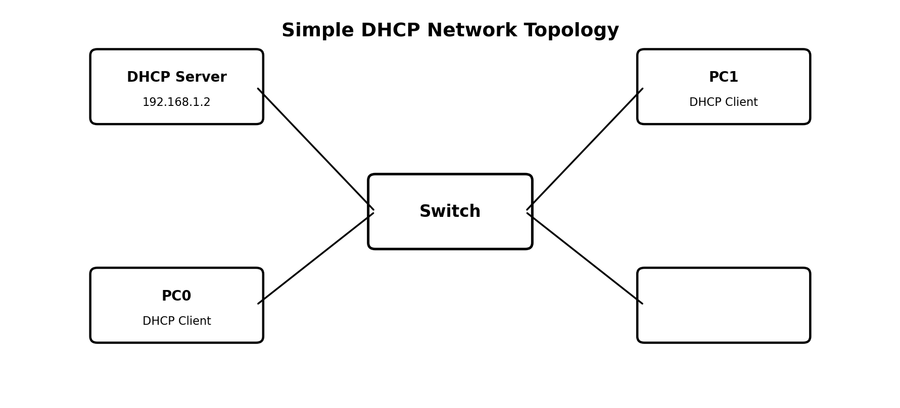
Suggested Addressing
Device | IP / Method | Subnet Mask
DHCP Server | 192.168.1.2 (Static) | 255.255.255.0
PC0 | DHCP | 255.255.255.0
PC1 | DHCP | 255.255.255.0

Procedure
- Open Cisco Packet Tracer and place one Server, one Switch (2960), and two PCs.
- Connect Server, PC0 and PC1 to the switch using Copper Straight-Through cables.
- Open Server > Desktop > IP Configuration. Set IP address 192.168.1.2 and subnet mask 255.255.255.0.
- Open Server > Services > DHCP and turn DHCP Service ON.
- Create a pool named LAN. Set Default Gateway to 192.168.1.1, Start IP Address to 192.168.1.10, Subnet Mask to 255.255.255.0, and Maximum Number of Users to 20. Click Add/Save.
- Open PC0 > Desktop > IP Configuration and click DHCP. Repeat the same on PC1.
- Verify that PC0 and PC1 receive different addresses, for example 192.168.1.10 and 192.168.1.11.
DHCP Server Pool Configuration
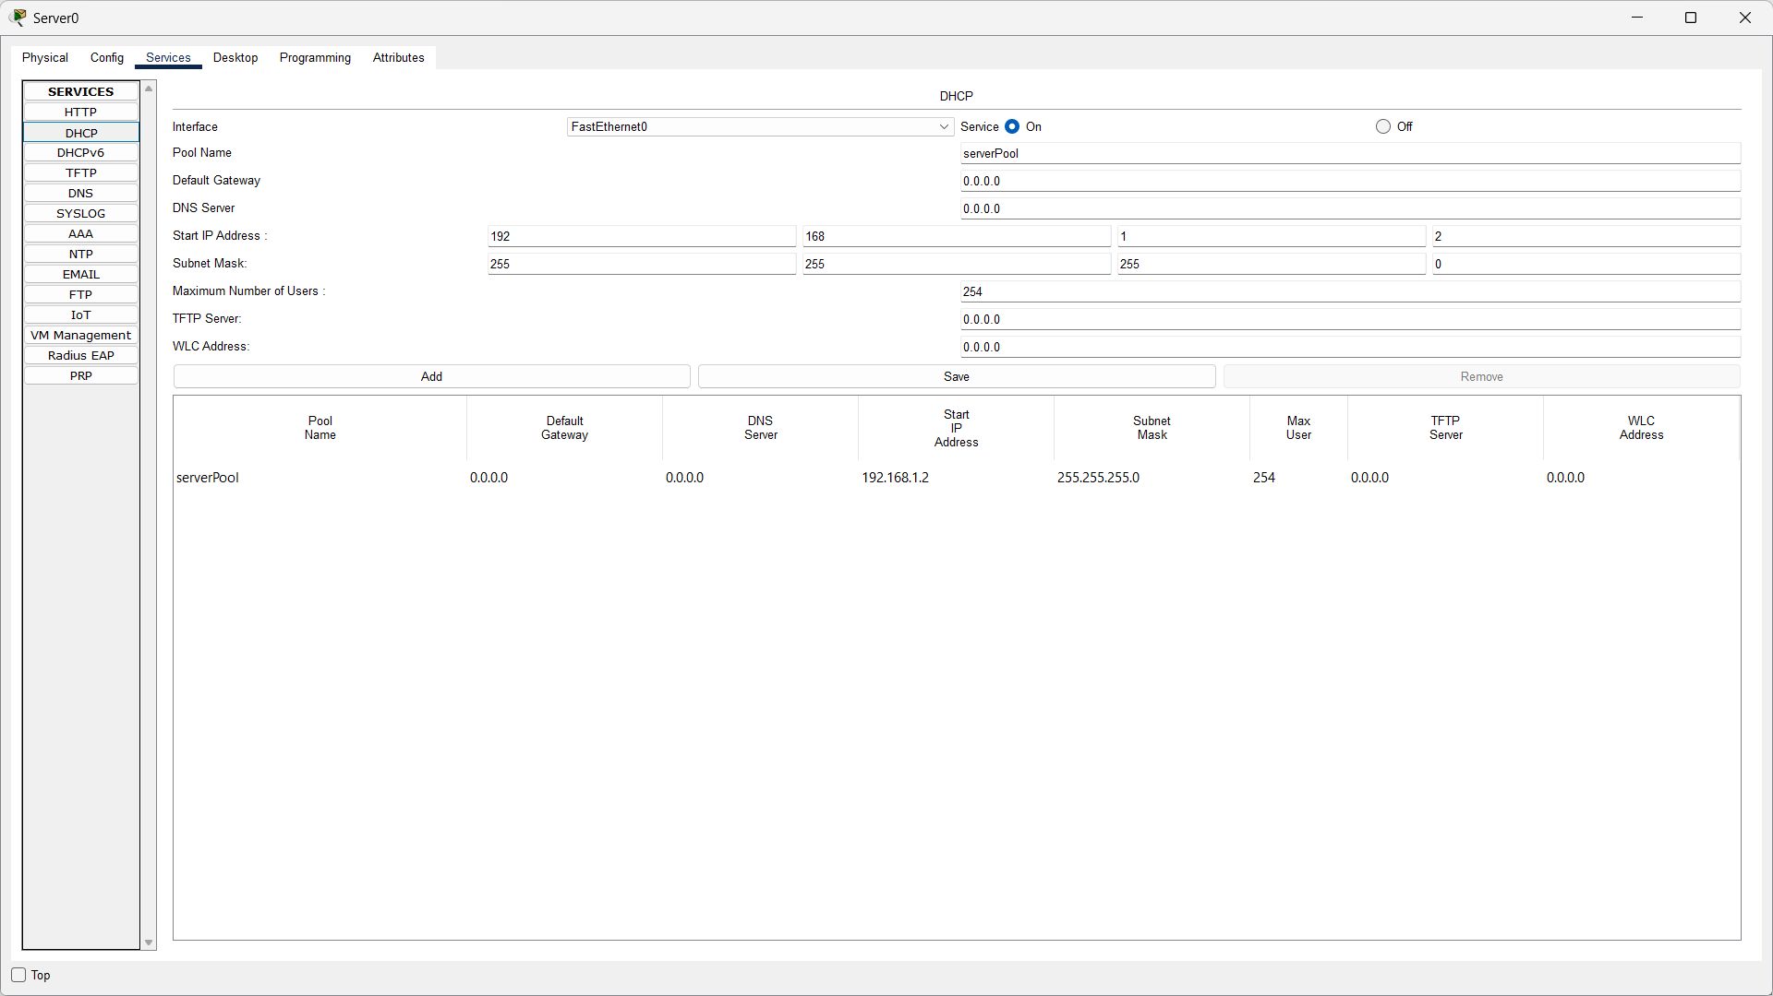
PC0 and PC1 DHCP IP Results
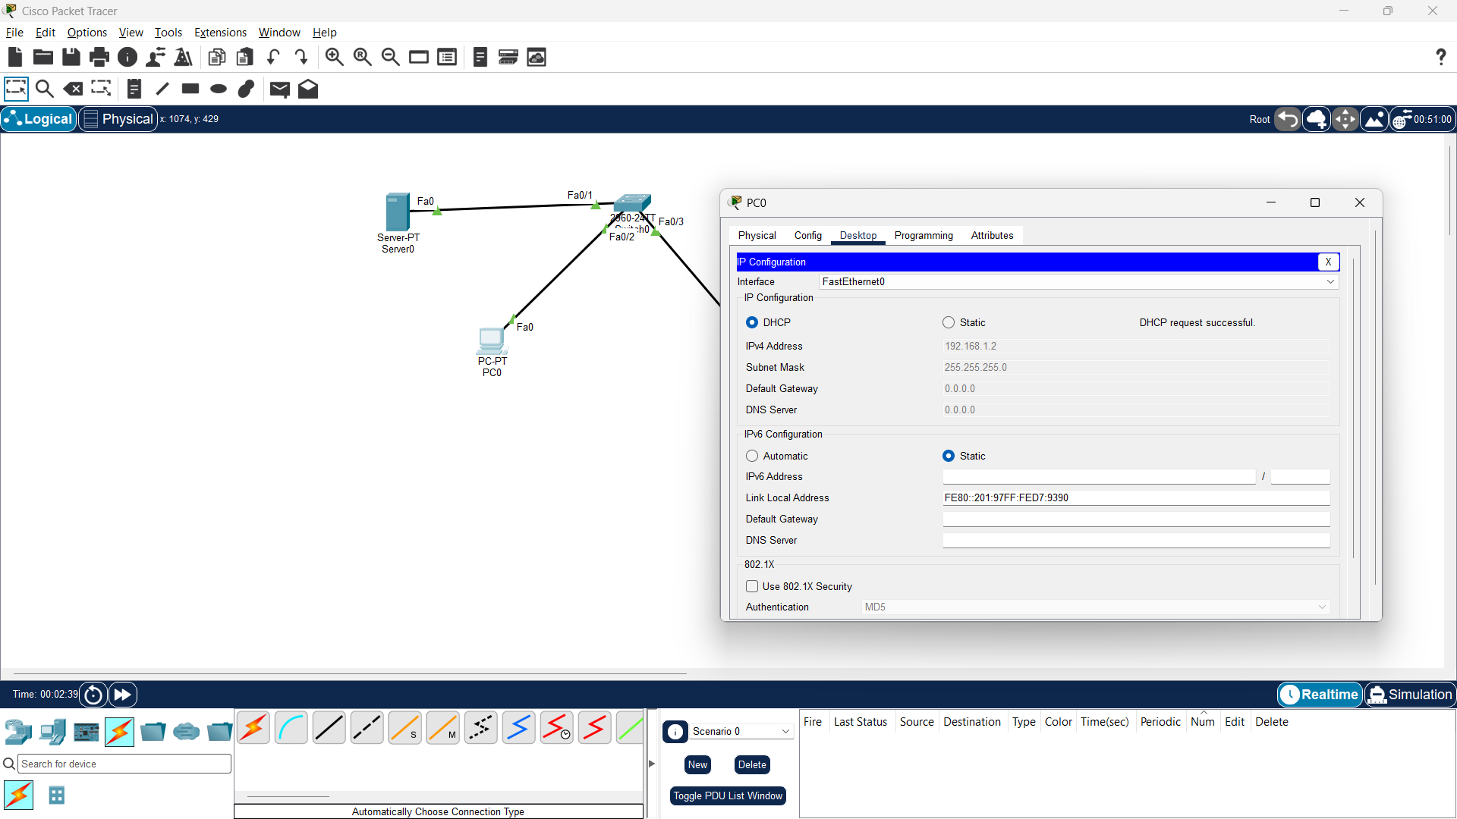
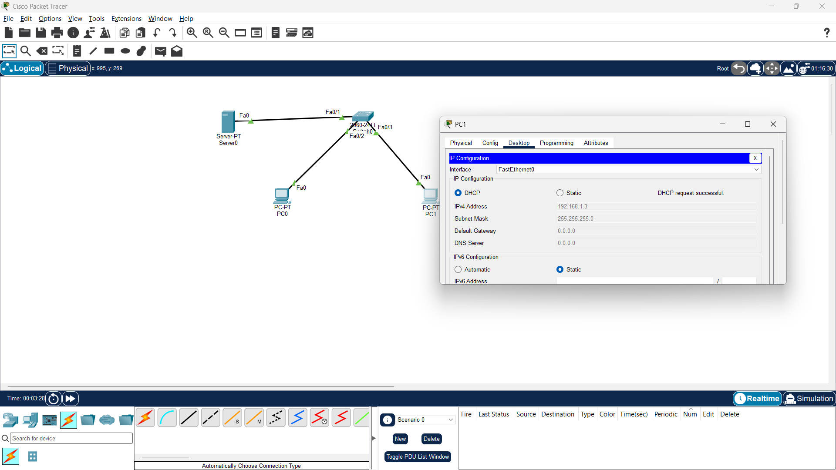
Result: The DHCP server automatically assigned a unique IP address to each client PC from the configured pool.

Q2.
DHCP normally uses four main messages. These are remembered as DORA: Discover, Offer, Request and Acknowledge.
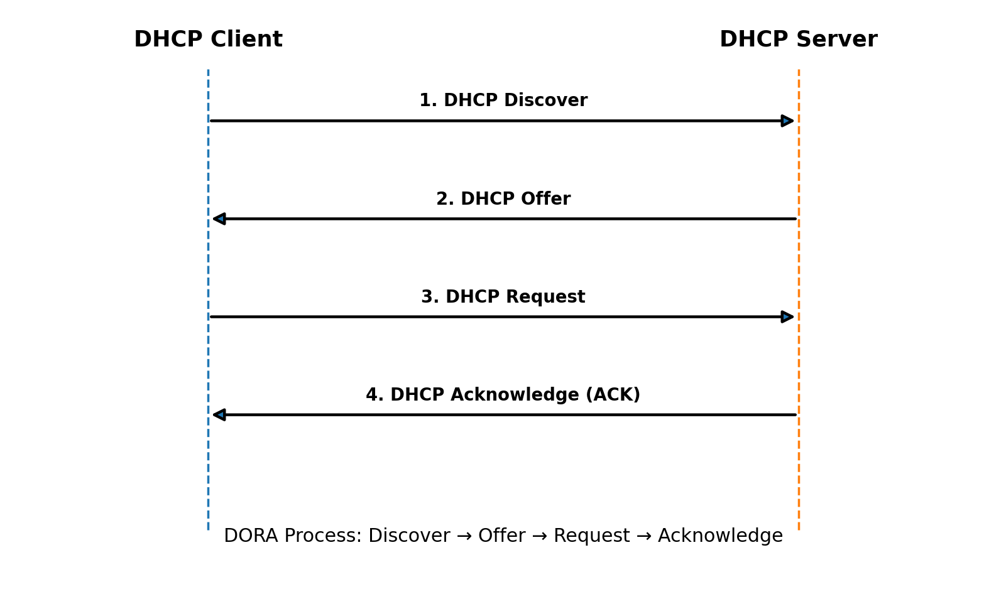
Step | Message | Direction | Meaning
1 | Discover | Client → Server | Client searches for a DHCP server.
2 | Offer | Server → Client | Server offers an available IP address.
3 | Request | Client → Server | Client requests the offered IP address.
4 | ACK | Server → Client | Server confirms the IP lease.
Result: The diagram shows how a client obtains an IP address automatically through the four-step DORA process.

Q3. DHCP Pool with Only One Available IP Address
Aim: Observe what happens when two PCs request DHCP addresses but the DHCP pool contains only one usable address.
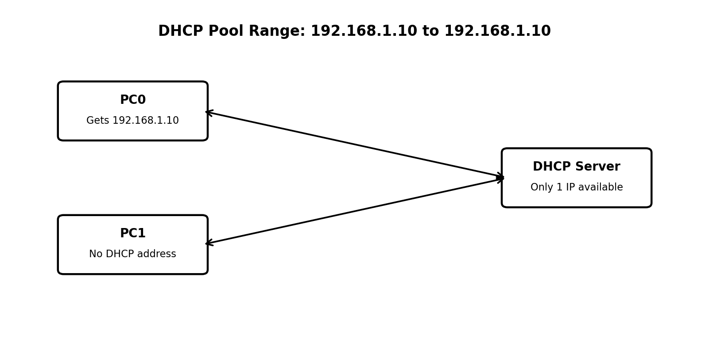

Procedure
- Open Server > Services > DHCP.
- Edit or create a DHCP pool with Start IP Address 192.168.1.10.
- Set Maximum Number of Users to 1. This makes only one DHCP address available.
- Connect two PCs to the switch and select DHCP in IP Configuration on both PCs.
- The first PC receives 192.168.1.10. The second PC cannot receive a normal address from this pool because no DHCP lease is left.
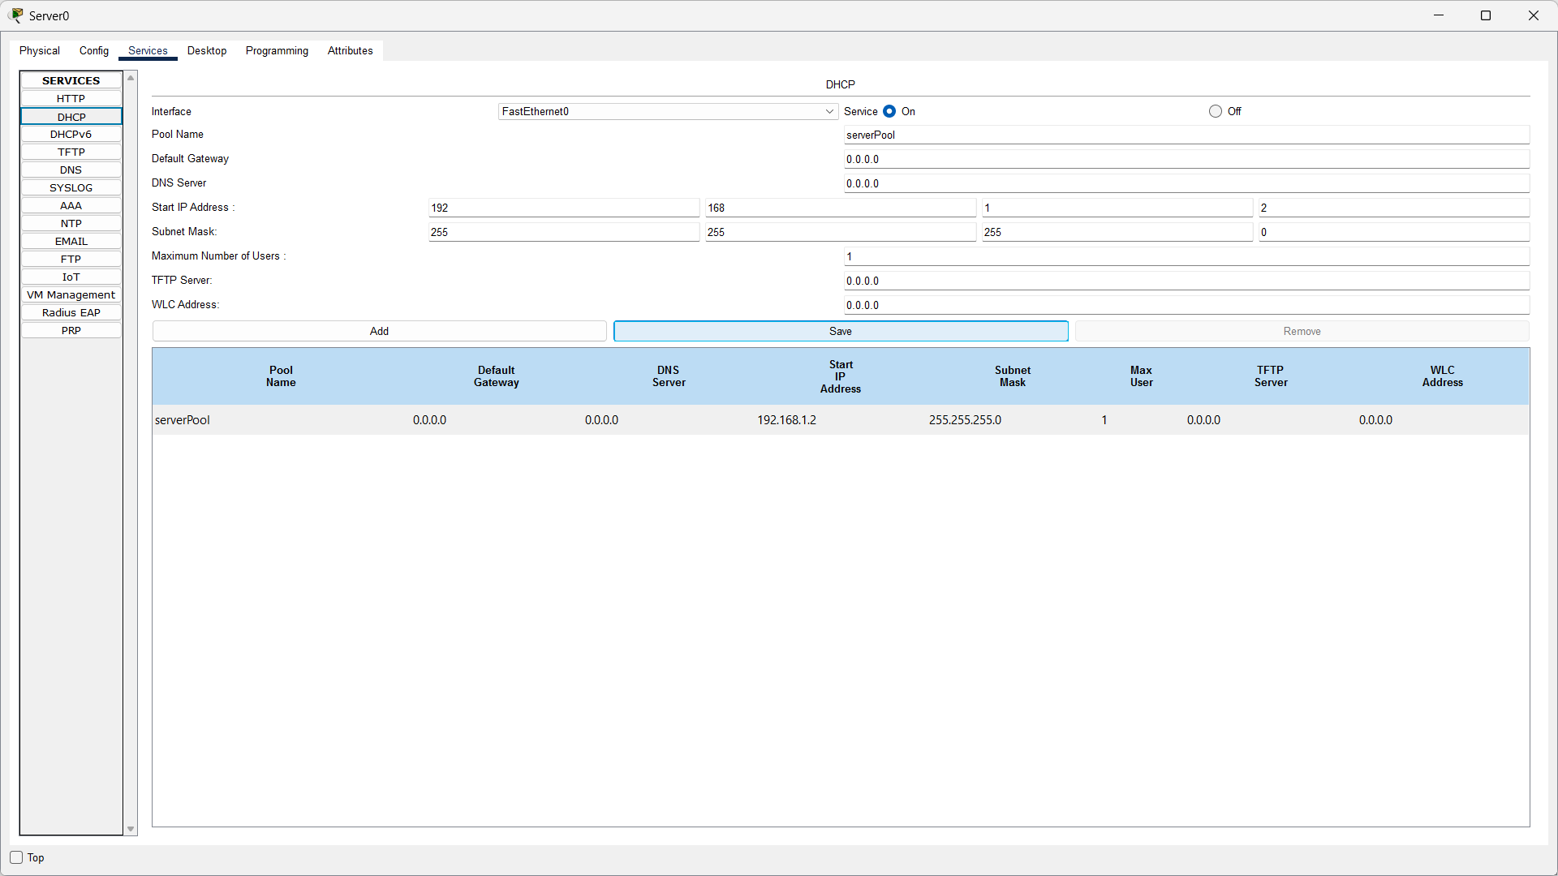
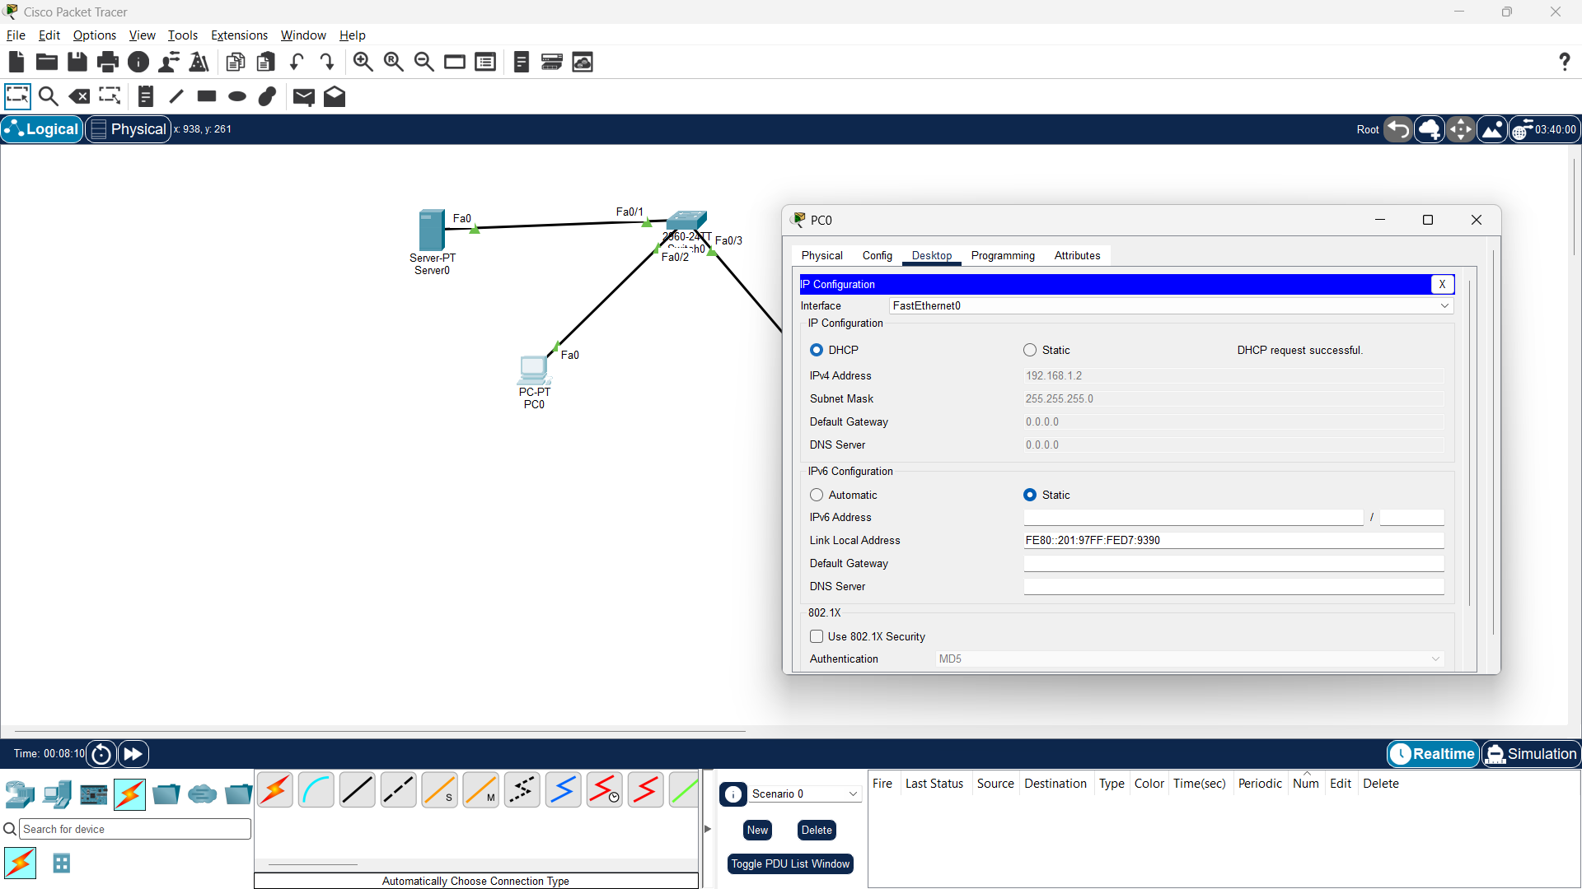
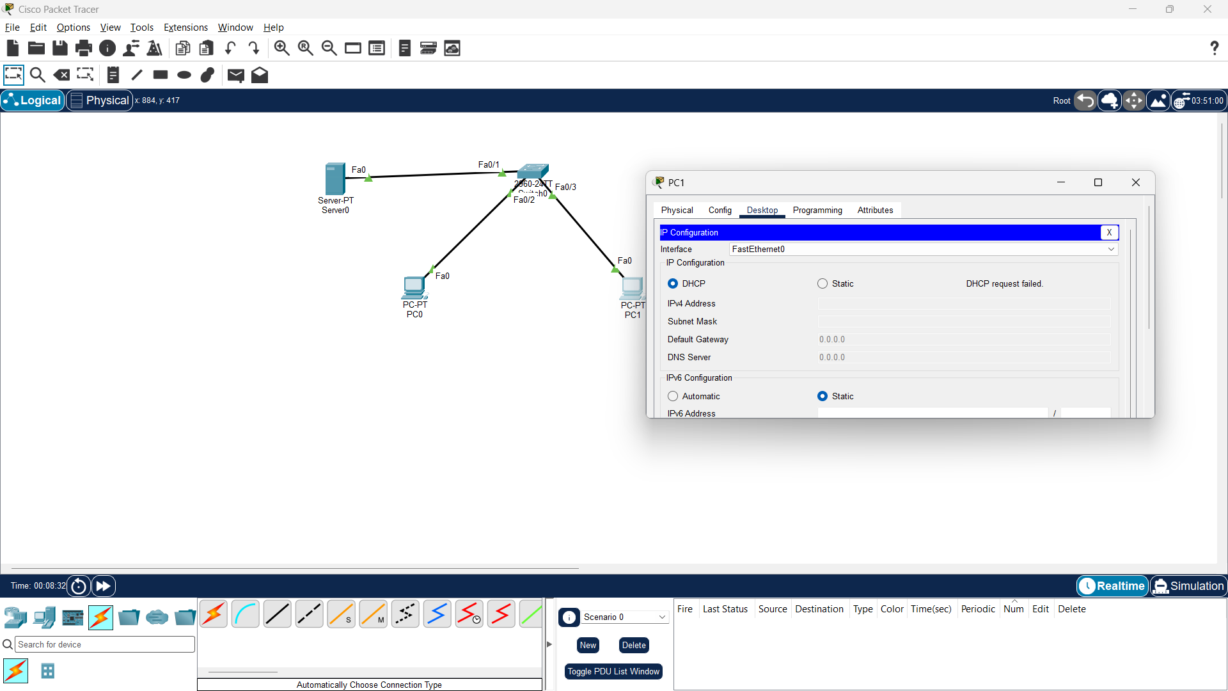

Explanation (2-3 lines)
Only one PC succeeds because the DHCP pool contains only one available IP address. After the first PC receives that address, the pool is exhausted. The second PC therefore cannot obtain another valid DHCP address until the lease becomes available or the pool is increased.

Q4. Zomato-Style Restaurant Wi-Fi DHCP Scenario
Scenario: A restaurant provides network access to customers. A laptop and a smartphone need IP addresses automatically. In Packet Tracer, a generic PC can be used to represent the smartphone.
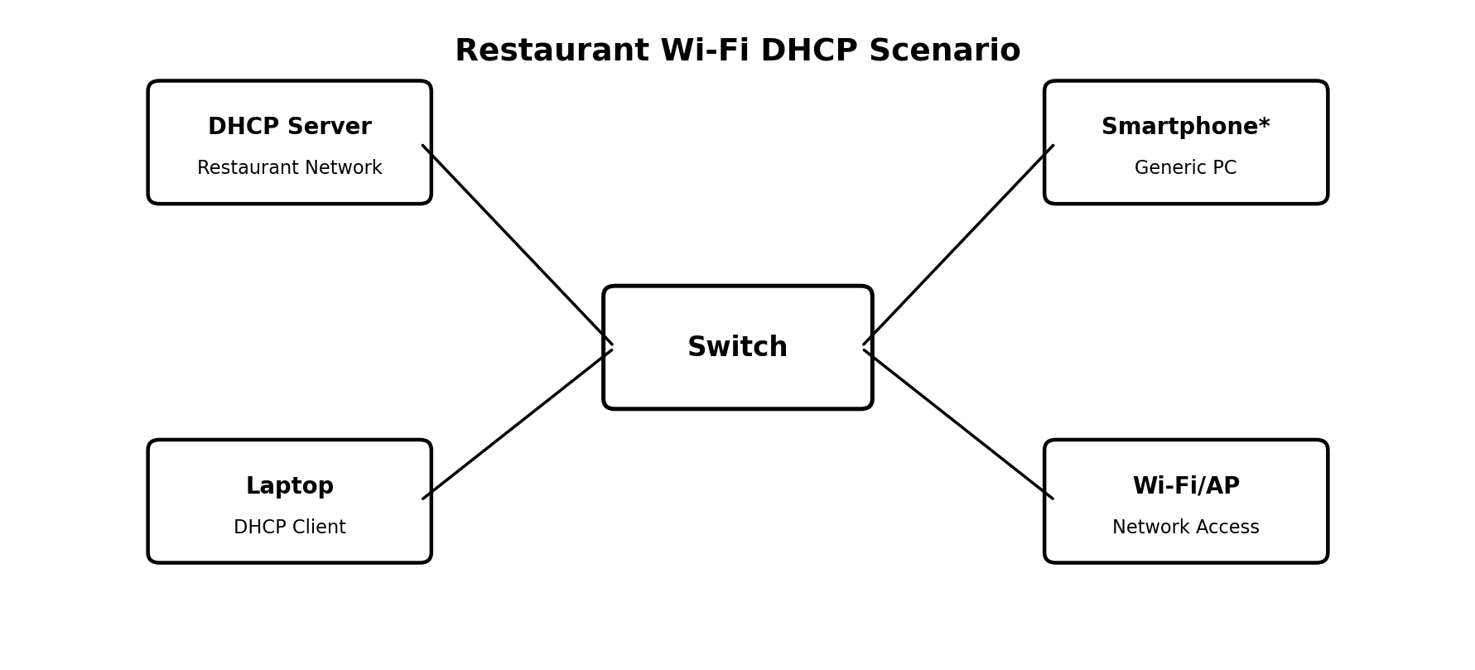

Example DHCP Settings
Setting | Example Value | Purpose
Server IP | 192.168.10.2 | Static address of DHCP server
Start IP | 192.168.10.100 | First customer address
Subnet Mask | 255.255.255.0 | Defines the local network
Default Gateway | 192.168.10.1 | Gateway/router address
Maximum Users | 50 | Allows many customer devices

Procedure
- Place a Server, Switch/Access Point, Laptop, and one generic PC to represent a smartphone.
- Configure the server with static IP 192.168.10.2/24.
- Open Services > DHCP, turn the service ON, and create a Restaurant_WiFi pool starting from 192.168.10.100.
- On the laptop and smartphone-PC, open IP Configuration and select DHCP.
- Verify that both devices receive different IP addresses, for example 192.168.10.100 and 192.168.10.101.

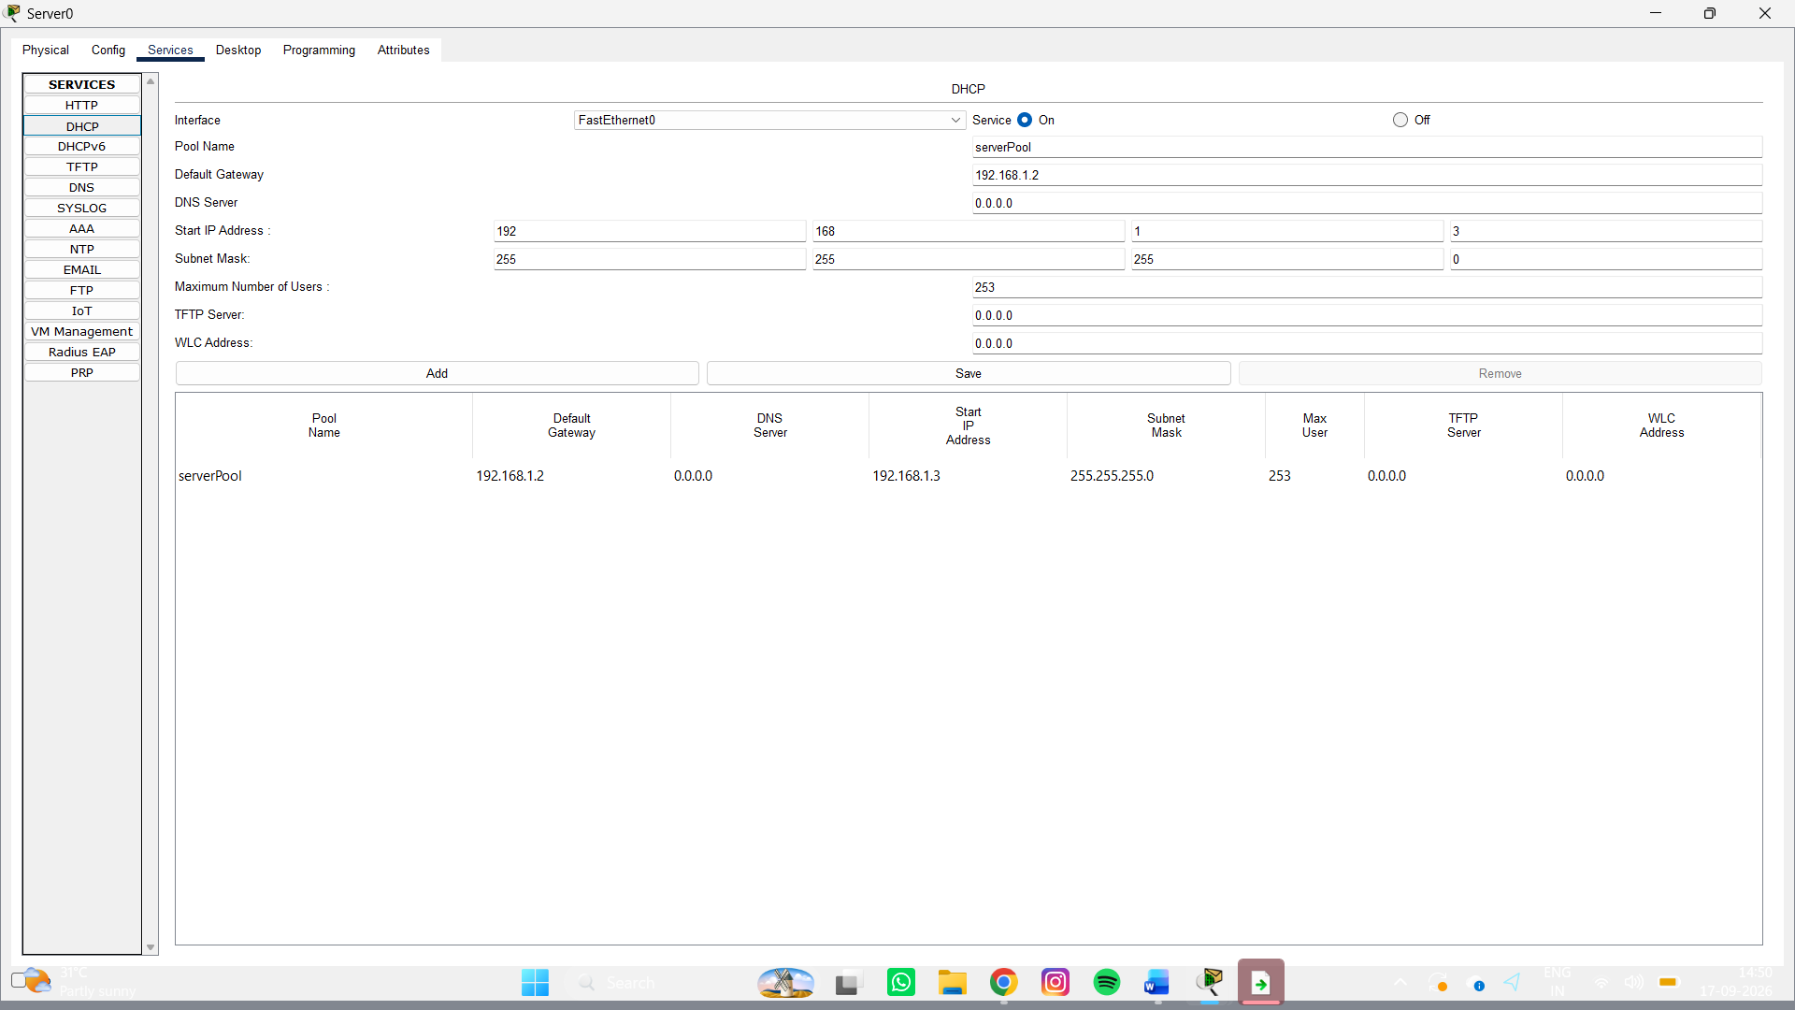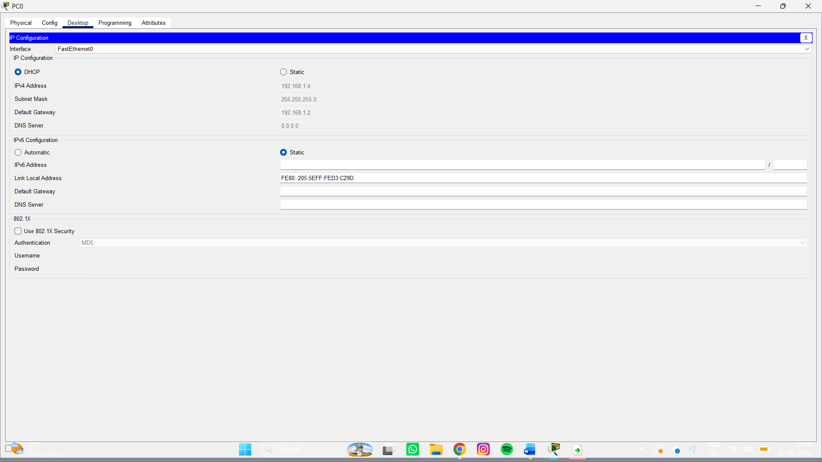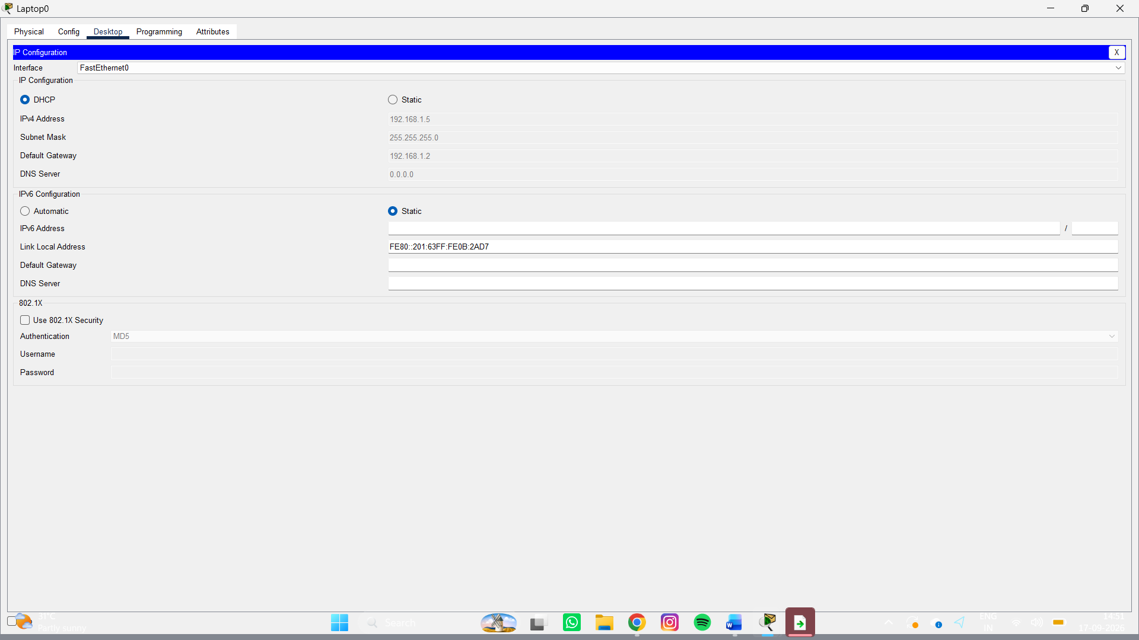

Why DHCP is Useful Here
DHCP is useful in a restaurant because customers connect and disconnect frequently. The server automatically gives each device a valid IP address, so staff do not need to configure every phone or laptop manually. It also reduces IP conflicts and makes the Wi-Fi network easier to manage.

Final Conclusion
In this practical assignment, DHCP was configured in Cisco Packet Tracer and tested with different situations. Two clients received unique addresses automatically, the DORA process was studied, a one-address DHCP pool demonstrated pool exhaustion, and a restaurant Wi-Fi example showed how DHCP is useful in real networks.

Screenshot Checklist
- Q1: DHCP server pool configuration.
- Q1: PC0 and PC1 showing different DHCP addresses.
- Q3: Two PCs after using a DHCP pool with only one address.
- Q4: Restaurant DHCP pool configuration.
- Q4: Laptop and smartphone-PC showing assigned IP addresses.
Note: The diagrams in this assignment are ready to use. Replace the empty screenshot boxes with your own real Cisco Packet Tracer screenshots.

